
Unit 2.2 - Introduction to Trig Functions
Creating Waves from Triangles Name:
Let’s consider a large clock that is hung on a wall such that the center of the clock is exactly 4 feet above the ground. The tip of the minute hand moves between a maximum of 5 feet and a minimum of 3 feet off the ground. Create a plot of the height of the tip of the minute hand starting from 12:00 am to 4:00 am. (The picture of the clock shows a time of roughly 1:00 am)

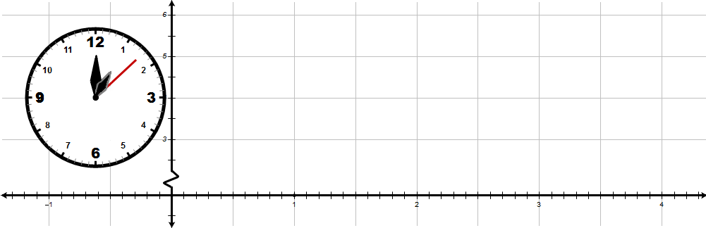
1:00
2:00
3:00
4:00
1:30
2:30
3:30
12:30

This plot should generate a cosine wave graph (see the animation on Matt’s Math Labs). Hopefully, this should make you ask, “How do functions that represent ratios of triangles generate smooth waves?”
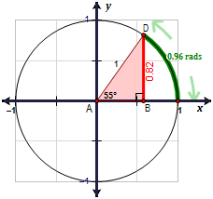

How Right Triangles create a WAVE: First consider a right triangle drawn inside of a unit circle like the one shown at the right. Determine the value of $sin\left(A\right)$. Try the example at the right find $sin\left(55°\right)$ which is approximately the same as finding $sin\left(0.96 rads\right)$.

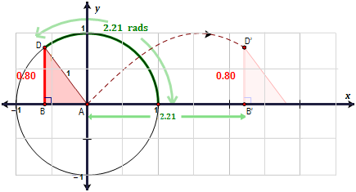

Then, if we plot each of point where x is the measure of the angle of the unit circle in radians and y is value of $sin\left(A\right)$ which is essentially the height of the right triangle for the given angle. The resulting locus of points generates a Sine Wave. The diagram below shows several more right triangles that map out more of the sine wave.

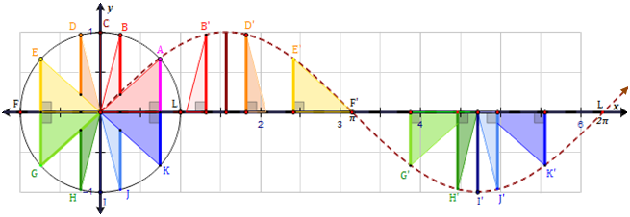

p.23

M. Winking (Section 2-2) ©

A Sine Wave is commonly described by 4 components.
Parts of a Sine Wave | Visual
Amplitude: The amplitude of a wave is the distance from the midline to highest point of the wave. (half of the vertical displacement.  $Amplitude= \frac{(Highest Y - Lowest Y)}{2}$ | 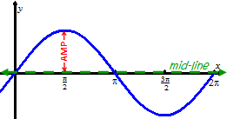
Period: The period of the wave is the horizontal distance of one complete cycle.  $Period= \left(Crest X\right)-\left(Previous Crest X\right)$  $Period= \left(Trough X\right)-\left(Previous Trough X\right)$ | 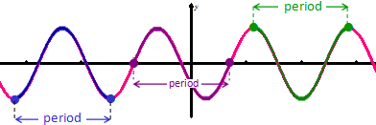
Phase Shift: The amount the wave is shifted right or left  $Phase Shift= \frac{\left(Crest X\right) + \left(Previous Trough X\right)}{2}$ | 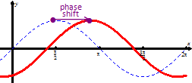
Vertical Shift: The amount the wave is shifted up or down  $Vertical Shift= \frac{(Highest Y + Lowest Y)}{2}$ | 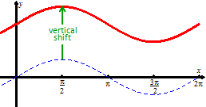

- Find a possible equation of the following graphs.
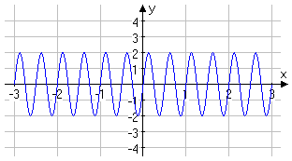
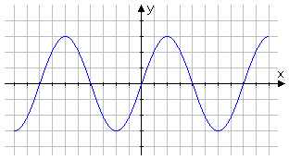
a. b.

Amplitude =

Period =

Phase Shift =

Vertical Shift =
Amplitude =

Period =

Phase Shift =

Vertical Shift =

p.24

M. Winking (Section 2-2) ©

- Find a possible equation of the following graphs.
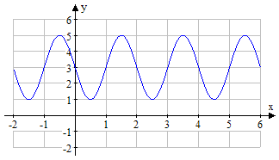
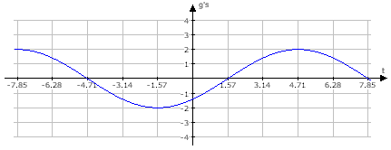
a. b.

Amplitude =

Period =

Phase Shift =

Vertical Shift =
Amplitude =

Period =

Phase Shift =

Vertical Shift =

c. d.
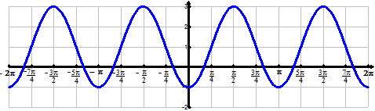
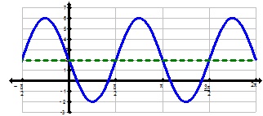

Amplitude =

Period =

Phase Shift =

Vertical Shift =
Amplitude =

Period =

Phase Shift =

Vertical Shift =

p.25

M. Winking (Section 2-2) ©

- Find a possible equation of the following graphs.
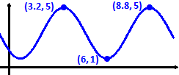
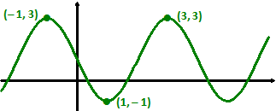
a. b.

Amplitude =

Period =

Phase Shift =

Vertical Shift =
Amplitude =

Period =

Phase Shift =

Vertical Shift =

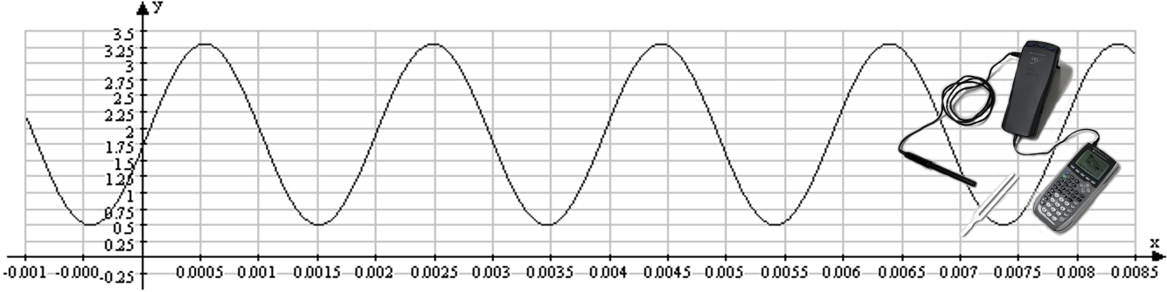
- The following is a graph of a tuning fork held up to a CBL microphone connected to a TI-84 Graphing Calculator.

- What is the amplitude? b. What is the Vertical Shift?

c. What is the Period? d. What is a possible Phase Shift?

e. What is a possible equation of the sound wave?
p.26

M. Winking (Section 2-2) ©

